Assignment 2

Students name:

Institutional affiliation:

Date:
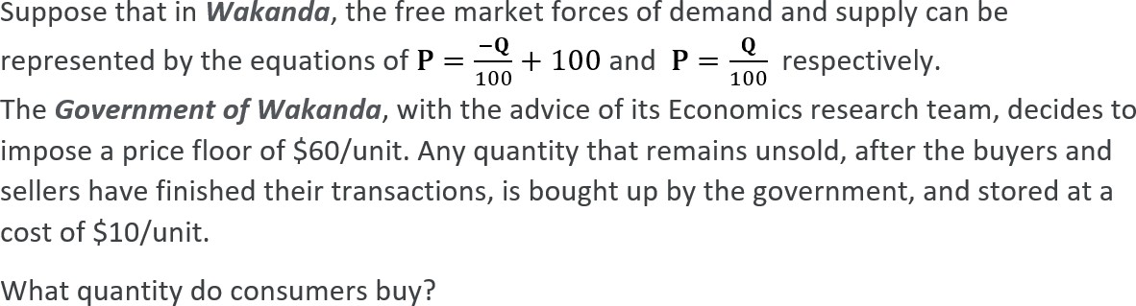
P=-Q/100+100
P=Q/100
Q/100=-Q/100+100
Q/100+Q/100=100
2Q/100=100
2Q=10000
Q=5000
a)4000 b5000 c)2000 d)6000

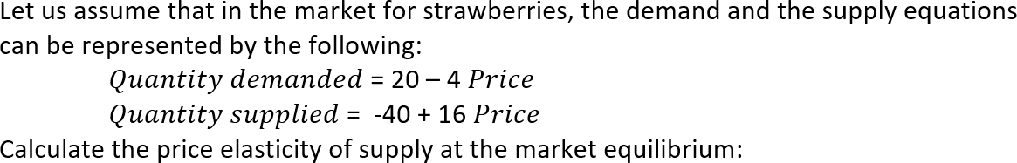

Qs=Qd
20-4p=-40+16p
60=20p
P=3
a) 3
b) 8
c) 6
d)16

In the year 2012, citizens of a small town consumed 470 units of wine. The price was $ 2 per unit. Economists of that town calculated the price elasticity of demand to be -0.4. derive the equation of the straight lie and determine the value of the vertical intercept of the linear demand curve

Linear equation- Qd=a-bP
470=a-2b

a)94
b)-1/94
c)2

d)7
Suppose a bottle of wine is currently selling for $40.00 per unit. The equilibrium price is $30.00 per unit. We would expect a

  - shortage to exist and the market price of a bottle of wine to decrease.
  - b) surplus to exist and the market price of a bottle of wine to decrease.
  - c) shortage to exist and the market price of a bottle of wine to increase.
  - d) surplus to exist and the market price of a bottle of wine to increase.
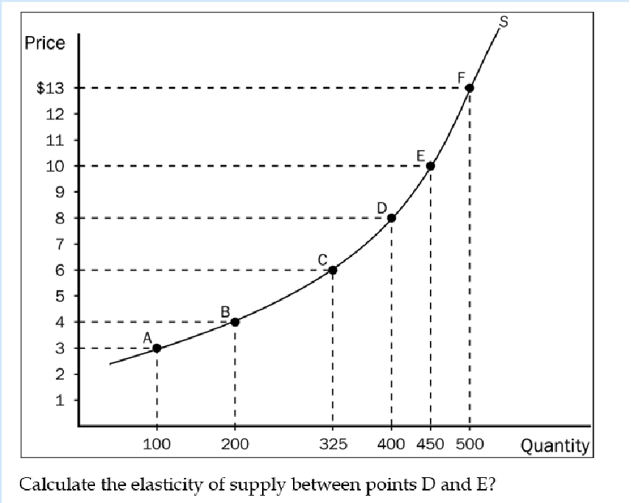
% Change in price (10-8)/(10+8)/2=2/9*100
=22.22
% Change in demand (450-400)/(450+400)/2=50/425*100
=11.765

Price elasticity=22.22/11.765
=1.89

a)0.53
b)1.26
c)1.89
d)0.34hh

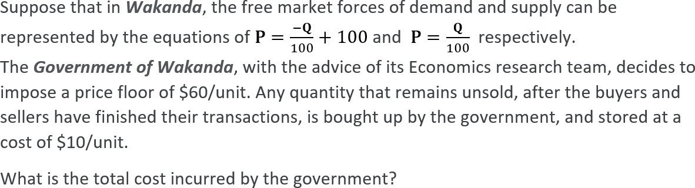
Consumer surplus 60=-Q/100+100
-40=-Q/100
Q=4000
Producer surplus 60=Q/100
Q=6000
Market surplus=10000
Cost incurred by government=10000*10
=100000

a)120000 b)10000 c)140000
d)160000

